JW MARRIOTT MARQUIS HOTEL SHANGHAI PUDONG

LOCAL STANDARD OPERATING PROCEDURE

LSOP No.: RM-HSKP-FC002 Effective Date: OCT 011, 2024

Division: Rooms Revised Date:

Section: Fitness Center Prepared by: Fitness Center Manager

Reviewed by: Director of Rooms Approved by: General Manager

SUBJECT 题目: Fitness Center Members and In-house guest register procedure
健身中心会员及住店客人登记制度

Objective:目的：

This policy provides detailed recording and control procedures for the guest use Fitness Centre facility.
对客人使用酒店健身中心设施进行有效的控制。

Policy & Procedure
政策及程序

Sign In
签到
Warmly greet all members and guests on arrival at the reception desk.
热情的对待所有到达健身中心前台的会员和酒店住客。

The receptionist must put the enough registration form on the reception desk in time for the Fitness center opening.
健身中心营业期间前台接待员必须在放置充足的客户登记表

After a member has presented their membership card at reception they should sign in the register information putting their name, sex, member number, locker number and time in. As for hotel guest need put their name, sex, room number, locker number and time in.
在会员出示了健身中心会员卡后，会员需要在登记单上记录他们的名字，性别，会员号码，更衣箱号码和进入的时间，如果是酒店住客则需要登记姓名，性别，房间号码，更衣箱号码和进入时间。

Active the facial recognition. whe the machine notifies “Please go with” or fingerprint identification passes. You can enter normally.
会员进入时主动刷脸识别，当机器通告“请同行”或指纹识别通过后方可正常进入。

If the member fails to register or refuses to enter face or fingerprint information, the FC receptionist will actively ask the guest's name and identify the membership card number and name. If it is consistent with the member information entered, after comparing the photo of the member, it is confirmed that it is used by the user, and then it can help to register the customer registration form and issue a hand card to allow entry
如会员未于登记或拒绝录入人脸或指纹信息时，前台主动询问客人姓名及识别会员卡编号与姓名，如与知录入会员信息符合一致，在比对本人照片后，确认为本人使用，方可协助帮忙登记客户登记表发放手牌准予进入

Upon verifying guest identification via opera system, member identification via membership system. Guest use number should accord with system for guest message.
住店客人则根据酒店OPERA系统里的客人信息进行核对。会员根据会员系统内的信息
进行核对。使用人数必须于系统里的信息符合。
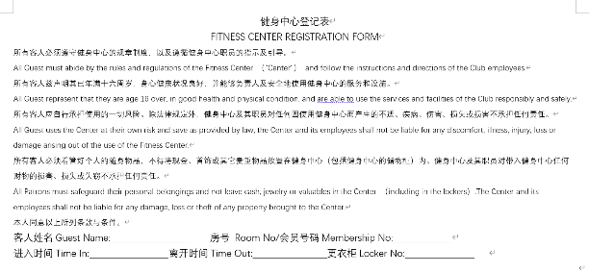

Signing out
签出

Members and guests when leaving the health center should put the time they left in the appropriate column.
当会员及酒店住客离开健身中心需要登记他们离开的时间。

Receptionist must make sure guests and members return the locker key, handset, slipper or towels when they left.
前台接待必须确保住店客人或会员在离开时归还更衣箱钥匙、耳机、拖鞋或毛巾。

When members and guests leave the fitness center you should always say a farewell comment “ Good bye Sir / Madame (or use their name if known)”.
当会员及住客离开健身中心时，前台接待员必须向客人道别（或用姓氏来称呼他们）

FC Registration Form Management and preservation
登记表的管理与保存

Daily registration forms are bound and stored in FC office. Filling in all forms in 3 months.
所有每日登记表均装订存放于健身中心仓库，存放周期不少于3个自然月。

Digital sign record is consistent with the manual registration form and save in Public disk
电子登记表内容及信息于实际手工登记表一致，且每日更新保存于酒店公共盘内。

